|  |  |  |  |  |  |  |  |  |  |  |  |  |
| --- | --- | --- | --- | --- | --- | --- | --- | --- | --- | --- | --- | --- |
| HANOI UNIVERSITY OF SCIENCE AND TECHNOLOGY  **SCHOOL OF ELECTRONICS AND TELECOMMUNICATIONS**  logo_128  **REPORT**  **VLSI DESIGN**   |  |  | | --- | --- | | **Giảng viên hướng dẫn:** | **TS. Nguyễn Vũ Thắng** | | **Sinh viên thực hiện:** | **Nhóm 5** |  |  |  | | --- | --- | | Phạm Quang Anh | 20182359 | | Trần Hồng Nhung | 20182713 | | Nguyễn Đức Quang | 20182736 | | Nguyễn Việt Thi | 20182798 |   Hà Nội, 7-2022 |

**MỤC LỤC**

[LIST OF FIGURES i](#_Toc109851046)

[LIST OF TABLES ii](#_Toc109851047)

[CHAPTER 1. DESIGN DOCUMENT 1](#_Toc109851048)

[1.1 Top module 1](#_Toc109851049)

[1.2 Pin description 1](#_Toc109851050)

[1.3 Parameter 2](#_Toc109851051)

[1.4 Functional description 2](#_Toc109851052)

[1.5 Architecture 3](#_Toc109851053)

[1.5.1 System architecture 3](#_Toc109851054)

[1.5.2 Write control 3](#_Toc109851055)

[1.5.3 Read control 3](#_Toc109851056)

[1.5.4 Comparator 4](#_Toc109851057)

[1.6 Timing 4](#_Toc109851058)

LIST OF FIGURES

[Figure 1.1 Top module 1](#_Toc109851059)

[Figure 1.2 System architecture 3](#_Toc109851060)

[Figure 1.3 Write control 3](#_Toc109851061)

[Figure 1.4 Read control 3](#_Toc109851062)

[Figure 1.5 Comparator 4](#_Toc109851063)

[Figure 1.6 Waveform when DATA\_WIDTH = 32 & FIFO\_DEPTH = 8 4](#_Toc109851064)

LIST OF TABLES

[Table 1.1 Pin description 1](#_Toc109851065)

[Table 1.2 Parameter 2](#_Toc109851066)

# DESIGN DOCUMENT

## Top module

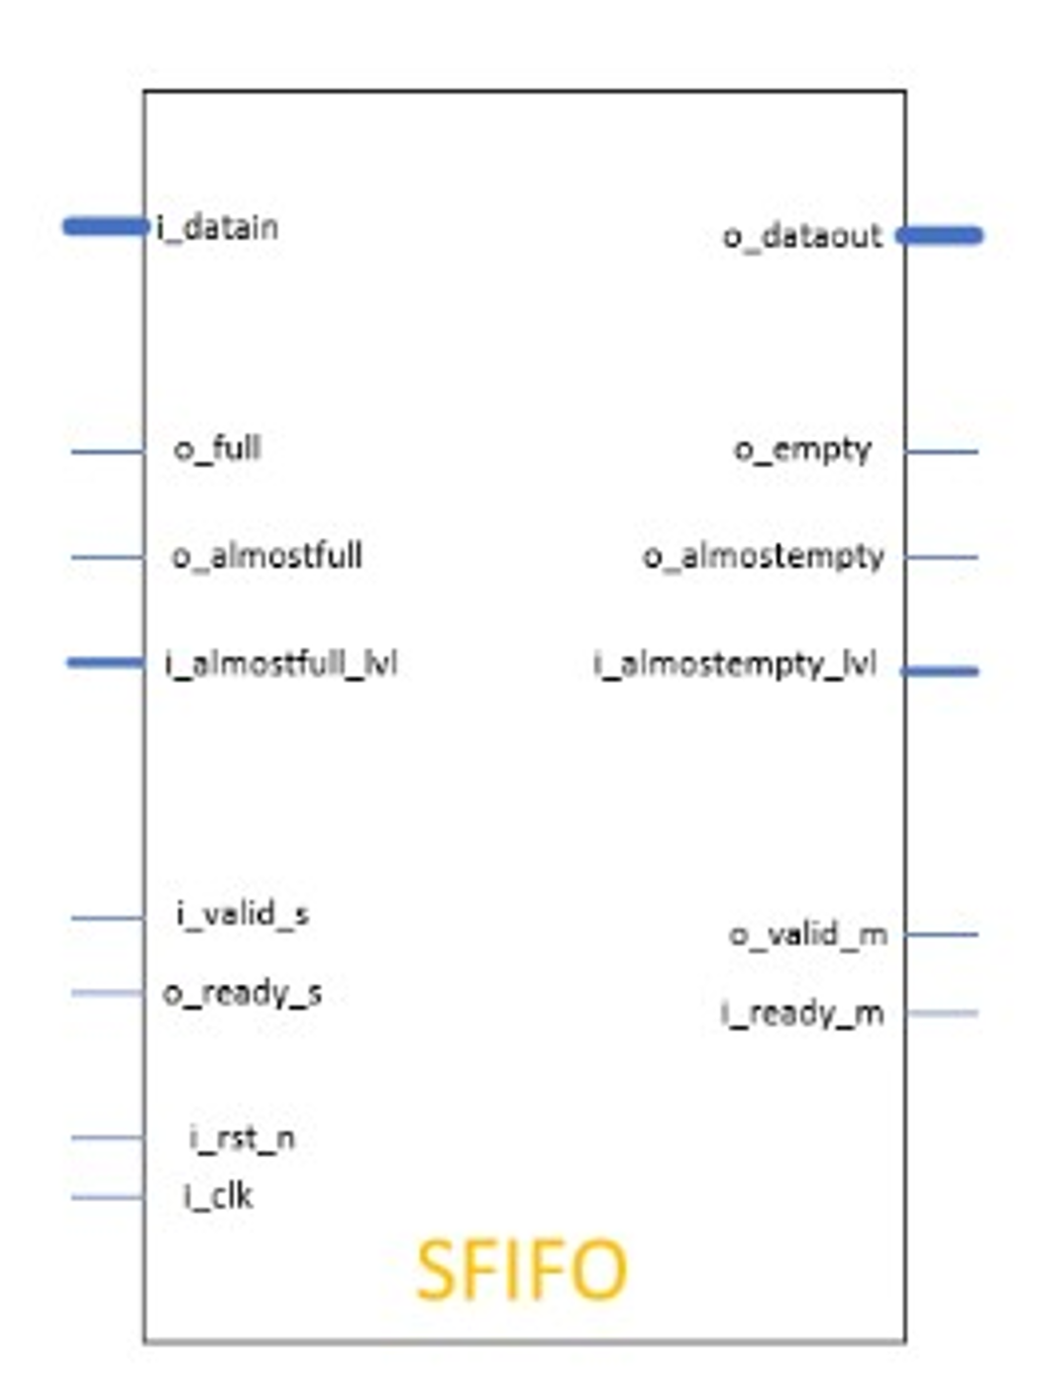

Figure . Top module

## Pin description

Table . Pin description

|  |  |  |  |
| --- | --- | --- | --- |
| **Pin Name** | **Width** | **Direction** | **Function** |
| i\_clk | 1 bit | Input | Source domain clock |
| i\_rst\_n | 1 bit | Input | Source domain asynchronous reset (active low) |
| i\_valid\_s | 1 bit | Input | Request write data into FIFO |
| i\_almostfull\_lvl | 8 bits | Input | The number of empty memory locations in the  FIFO at which the o\_almostfull flag is active |
| i\_datain | 32 bits | Input | Push data in FIFO |
| i\_ready\_m | 1 bit | Input | Request read data from FIFO |
| i\_almostempty\_lvl | 8 bits | Input | The number of empty memory locations in the  FIFO at which the o\_almostempty flag is active |
| o\_ready\_s | 1 bit | Output | Status write data into FIFO (if FIFO not full  then o\_ready\_s = 1) |
| o\_almostfull | 1 bit | Output | FIFO almostfull flag (determined by i\_almostfull\_lvl) |
| o\_full | 1 bit | Output | FIFO full flag |
| o\_valid\_m | 1 bit | Output | Status read data from FIFO (if FIFO not empty  then o\_valid\_m = 1) |
| o\_almostempty | 1 bit | Output | FIFO almostempty flag (determined by i\_almostempty\_lvl) |
| o\_empty | 1 bit | Output | FIFO empty flag |
| o\_dataout | 32 bits | Output | Pop data from FIFO |

## Parameter

Table . Parameter

|  |  |  |
| --- | --- | --- |
| **Parameter** | **Values** | **Descriptions** |
| FIFO\_DEPTH | 256 | Depth of FIFO |
| DATA\_WIDTH | 32 | Width of data |

## Functional description

* if reset is actived then read/write pointers are zero; full/almostfull flags clear; empty/almostempty flags set.
* FIFO not empty o\_valid\_m set; FIFO not full o\_ready\_s set.
* almostempty/almostfull flags set when FIFO almost empty/full dependent on almost empty/full level.
* Read enable if i\_ready\_m set and FIFO not empty; Write enable if i\_valid\_s set and FIFO not full.
* Read pointer don't change if FIFO empty; Write pointer don't change if FIFO full.
* When FIFO is full, o\_full is set
* When FIFO is empty, o\_empty is clear

## Architecture

### System architecture

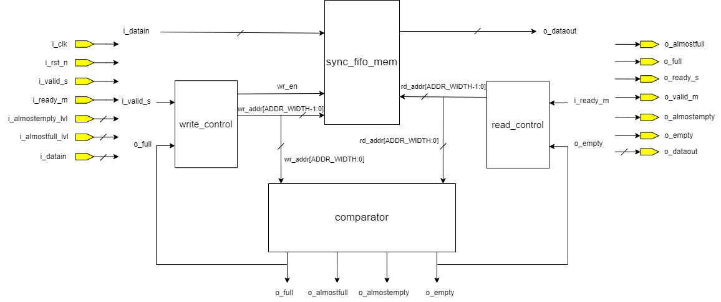

Figure . System architecture

### Write control

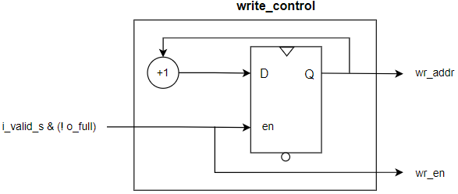

Figure . Write control

### Read control

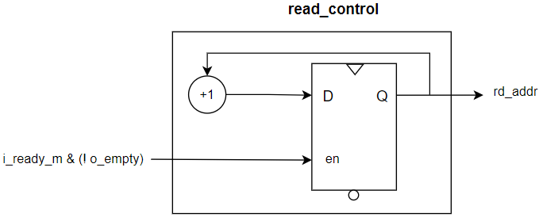

Figure . Read control

### Comparator

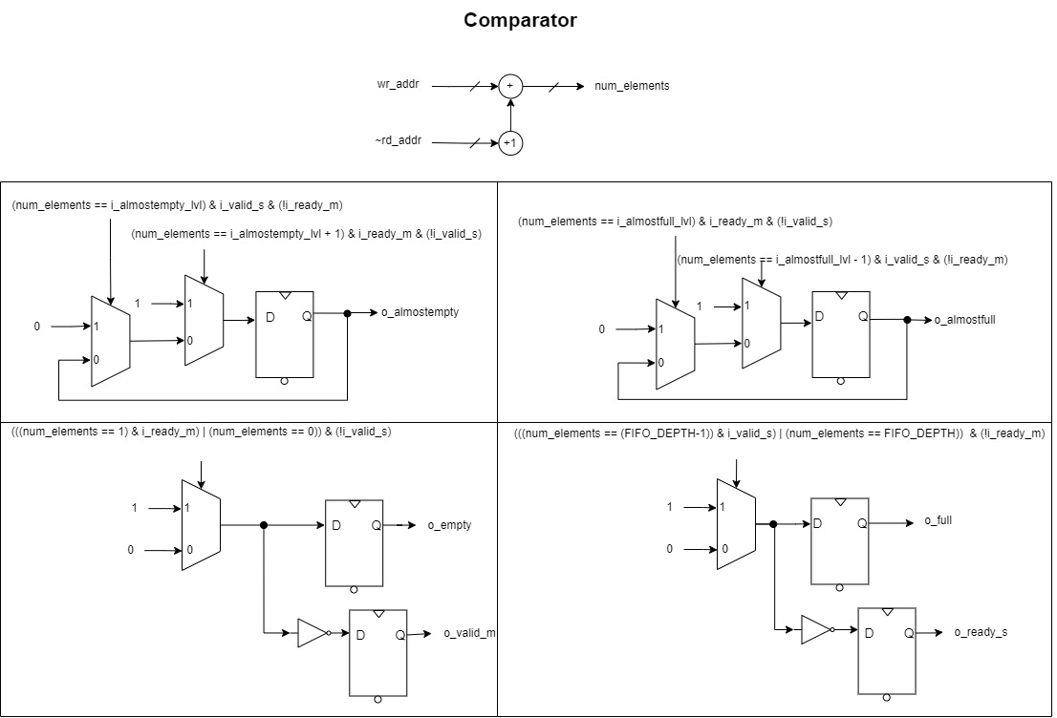

Figure . Comparator

## Timing

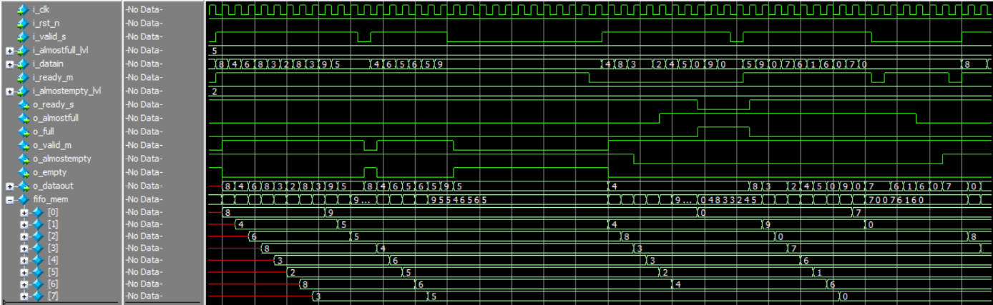

Figure . Waveform when DATA\_WIDTH = 32 & FIFO\_DEPTH = 8